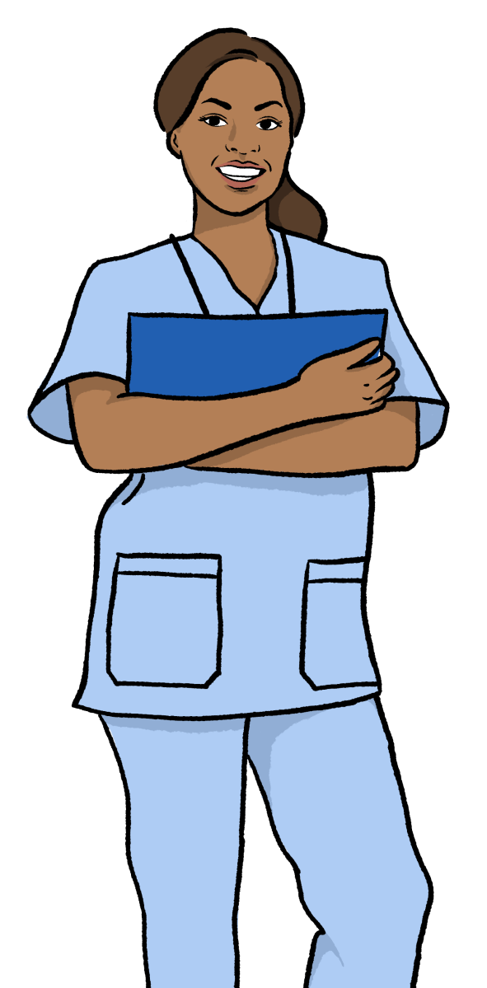




The Accessible Information Standard
What is your experience with health and care services?

1

Contents
 | Page
Introduction | 3
Survey questions | 5
About you | 16
For more information | 25

In this Easy Read document, difficult words are in bold. We explain what these words mean in the sentence after they have been used.


Some words are pink and underlined. These are links which will go to another website which has more information.
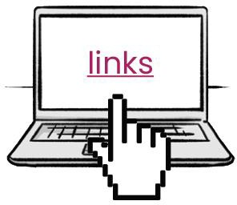

Introduction



We are Healthwatch. We work to make sure health and care services are the best they can be for the people who use them.



We want to hear about your experience with health and care services when they:
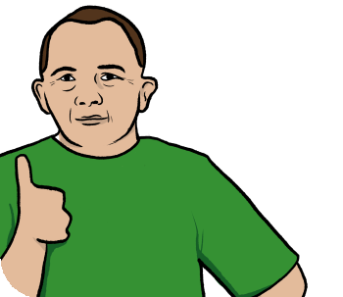

- communicate with you, and
- give you information.

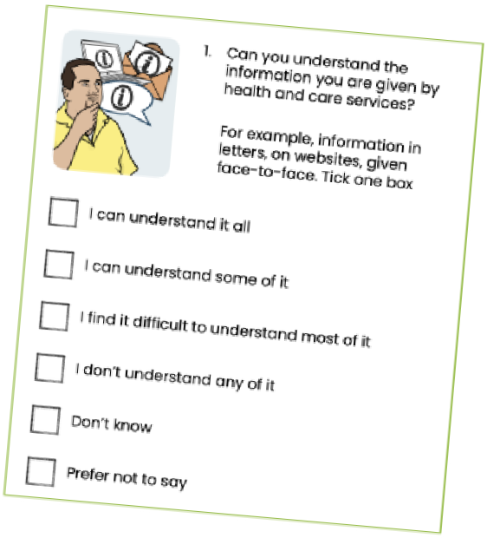

Please tell us about your experience by answering the questions in this survey.

Your answers will help us to talk to health and care services about how they can improve.

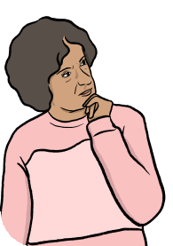
Accessible Information Standard

Accessible Information Standard

This survey is part of our campaign to make people aware of the Accessible Information Standard.


The Accessible Information Standard is a law that says all health and care services have to:

How can we support you?
- communicate in different ways for people with different needs.



- provide information that is clear
and easy for people to
understand.
Survey questions







1. Can you understand the information you are given by health and care services?

For example, information in letters, on websites, given face-to-face. Tick one box

I can understand it all

I can understand some of it

I find it difficult to understand most of it

I don’t understand any of it

I don’t know

Prefer not to say

Can you support
me to understand this information?
2.When using health or care services, have you ever asked for support to help understand any information you have been given? Tick one box
Yes
No
I don’t know
Prefer not to say

Can you support me to get in
contact with you?
3. When using health and care services, have you ever asked for support to help you contact health or care services?
Tick one box
Yes
No
I don’t know
Prefer not say

Can you support me to communicate with
you?
4. When using health or care services, have you ever asked for support to help you communicate with staff?
Tick one box
Yes
No
I don’t know
Prefer not to say


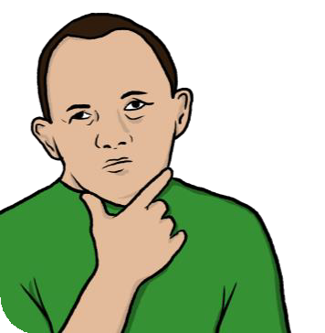

5. How do you find getting support from health and care services to understand information, contact them and communicate with staff?
Tick one box

I don’t need any support so I have never asked

I always get the support I need

I sometimes get the support I need

I don’t really get the support I need

I didn’t know I could get support so
I have never asked

I don’t know

Prefer not to say

Can you give me information in a way I can understand?
6. Has a health or care service ever refused to give you information in a way you can understand, even though you asked for it? Tick one box
Yes
No
I don’t know
Prefer not to say
Can you support
me to understand the information?
7.Has a health or care service ever refused to support you to understand information, even though you asked for it? Tick one box
Yes
No
I don’t know
Prefer not to say
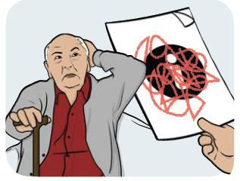


- What happened because of not being given information in a way that you could understand? Tick all that apply

I missed my appointment
I couldn’t contact the service that I needed
I couldn’t understand how to take my medication
I took the wrong dose of my medication I got the wrong medication
I couldn’t understand and communicate
with staff
I missed out on important information about my health
I didn’t know what I needed to do to keep myself safe from Covid-19
It affected my mental health and wellbeing It didn’t affect me in any way
Other - please say




- Have you found it difficult to use any of these services because of communication problems? Tick all that apply

GP services - this is your local doctor
Dentist

A&E - this is the accident and emergency department at hospital
NHS 111
Mental health services Hospital appointments Hospital treatment Covid-19 vaccinations Social care
Other - please say

How do I feel about asking?
- How do you feel about asking health or care services to provide information in a way that you can easily understand? Tick one box




I feel very comfortable asking health services to provide information in a way I can understand

I feel quite comfortable asking health services to provide information in a way I can understand

I feel a bit uncomfortable asking health services to provide information in a way I can understand

I feel very uncomfortable asking health services to provide information in a way I can understand

I don’t know

Prefer not to say

I can’t ask
- What stops you from asking services to provide information or communicate with you in a way that you can easily understand? Tick all that apply



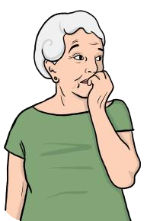

The attitude of staff
How confident I feel
My ability to communicate with staff
The amount of support I get from my friends and family
Whether I can get information in a way that
suits my needs
I have had a bad experience before Other reasons - please say

None of the above
I don’t know Prefer not to say

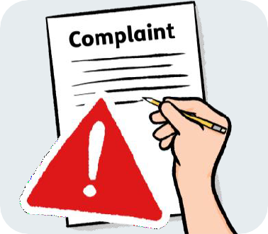

12. If you are not given support with communication or information in a way you can understand, do you know how to complain about it?
Tick one box
Yes No
I don’t know Prefer not to say
This doesn’t apply to me


13. Has anything changed about the way health and care services communicate with you since Covid-19 started? Tick one box

Yes - it is much better now Yes - it is a bit better now Nothing has changed
Yes - it is a bit worse now Yes - it is much worse now I don’t know
Prefer not to say

About you

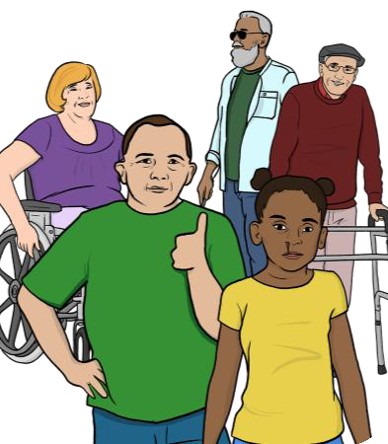

These questions ask for some information about you.
We want to make sure we are hearing from people from different backgrounds, and understand different experiences.

You don’t have to answer these questions if you don’t want to.

14. How would you describe your ability to speak, understand and read English?
Tick one box
I can speak, understand and read English well
I can speak, understand and read some English
I can’t speak, understand or read English at all
I don’t know
I prefer not to say




- Do you have any of the following conditions? Tick all that apply

I have sight loss
I have hearing loss

I have a mental health condition which affects my ability to communicate or understand information

I have a learning disability that affects my ability to communicate or understand information

I have another condition that affects my ability to communicate or understand information - please say

None
I don’t know Prefer not to say



- How old are you? Tick one box

16 to 17 years
18 to 24 years
25 to 49 years
50 to 64 years

65 to 79 years

80+ years Prefer not to say Not known


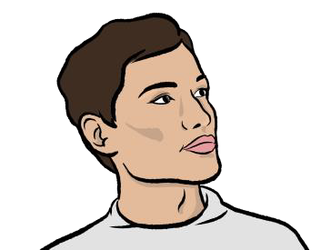
- How do you describe your gender? Tick one box

Woman
Man

Non-binary - you don’t feel yourself to be either male or female

Intersex - you have male and female parts of your body

I prefer to use my own word - please say

Prefer not to say Not known

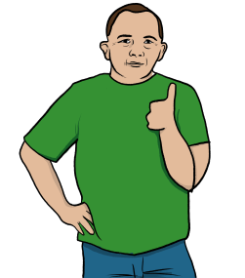




- How would you describe your ethnicity? Tick one box

Arab

Asian / Asian British: Bangladeshi

Asian / Asian British: Chinese Asian / Asian British: Indian Asian / Asian British: Pakistani
Asian / Asian British: Any other Asian / Asian British background

Black / Black British: African Black / Black British: Caribbean
Black / Black British: Any other Black / Black
British background

Mixed / Multiple ethnic groups: Asian and White

20

Mixed / Multiple ethnic groups: Black African
and White

Mixed / Multiple ethnic groups: Black Caribbean and White

Mixed / Multiple ethnic groups: Any other Mixed / Multiple ethnic groups background

White: British / English / Northern Irish / Scottish / Welsh

White: Irish

White: Gypsy, Traveller or Irish Traveller

White: Roma

White: Any other White background

Any other ethnic group

Prefer not to say

Not known



- Which of the following best
describes your financial status
- this means how much money you have to live on?
Tick one box

I have more than enough for the basic things
I need to live, and a lot more to spend on extra things I want

I have more than enough for the basic things
I need to live, and a bit more to spend on extra things I want

I have just enough for the basic things I need to live

I don’t have enough for the basic things I need to live

I don’t know

Prefer not to say
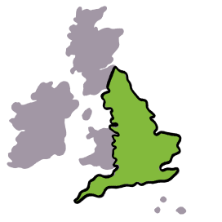



20. Which area of the country do
you live in?

21. To help us make sure more health and care services follow the Accessible Information Standard, we want to share people’s experiences.
Would you be happy to tell us your story so that we can share it with other people?
Yes

No

22. If you said ‘Yes’ to sharing your story, please tell us your:
Name: Email address:

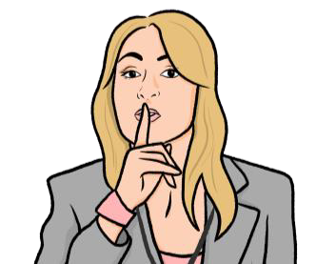
Personal information
We will keep your name and email address safe and private.


We follow the law about keeping all personal information safe and private. You can read our Privacy Policy here: www.healthwatch.co.uk/privacy


Please tick this box to say that you understand that we will keep your information safe:
I understand

Send us your completed survey
Post your survey to our Freepost address:

FREEPOST RTUL-UBEJ-ERCA
Healthwatch Cornwall 6 Walsingham Place TRURO
TR1 2RP

Email it to admin@healthwatchcornwall.co.uk

For more information
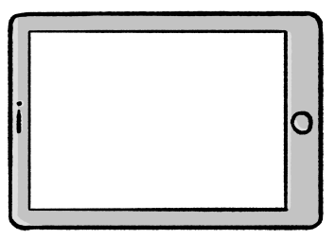

To find out more you can visit our website:
www.healthwatch.co.uk/advice- and-information/2022-01- 18/accessible-information- standard-what-you-can-expect- services

