Outreach and Engagement

Annual Review

April 2018 to
March 2019

Michelle Hooker
Outreach and Engagement
INDEX

- Summary

- Background

- Cornwall Statistics/ Barriers

- Resources for Engagement

  - Volunteers
  - Volunteer Resources
  - Drop-In Recording Form
  - Have Your Say Form
  - Corporate Presentation
  - Newsletter Sign-Up
  - Events Spread-sheet
  - Sign posting Spread sheet

- Work Undertaken/ Projects
  - Hospital Drop-In’s
  - Community Events
  - Support Groups
  - Networking
  - Visiting Times
  - Care Opinion
  - Outreach and Engagement Statistics

- Partnerships/ Joint Working
  - Healthwatch Plymouth
  - Patient Experience Groups/ PALS teams/ Hospital Trusts
  - Interagency Meetings
  - SWASFT

- Recommendations for Future

Annex 1 PESTEL

Annex 2 SWOT

- SUMMARY

This report has been created to feedback the activities and outcomes of the Outreach and Engagement Team for the past financial year 2018/19.

This report will highlight the projects, partnerships and outcomes the team has achieved to date; how it has influenced and supported different projects and identifies the priorities and recommendations for the next 12 months.

- BACKGROUND

The Healthwatch Cornwall (HC) three year Strategy (2018-2021) highlights when we listen and act on the voice and experiences of people who use health and social care services, then provision is improved. HC strategy includes our 9 priorities of:

- Gathering and reporting insights
- Representation within decision making systems
- Research into areas of public interest
- Shaping Our Future
- Quality of Health and Social Care Services
- Partnership Boards
- Mental Health
- End of Life Care
- Demonstrating Impact

Our Vision is to inspire positive change in Cornwall’s health and social care through effective public engagement.

Our Mission is to make sure people’s views and experiences influence decision making at the heart of Cornwall’s health and social care.

To gather the views of people, there is a dedicated outreach and engagement team within the HC structure. The past 12 months have been challenging for the outreach team, however it has continued to maintain excellent engagement opportunities. The team have still managed to co-ordinate and attend regular drop-in’s, as well as a range of small, medium and large scale events across the County.

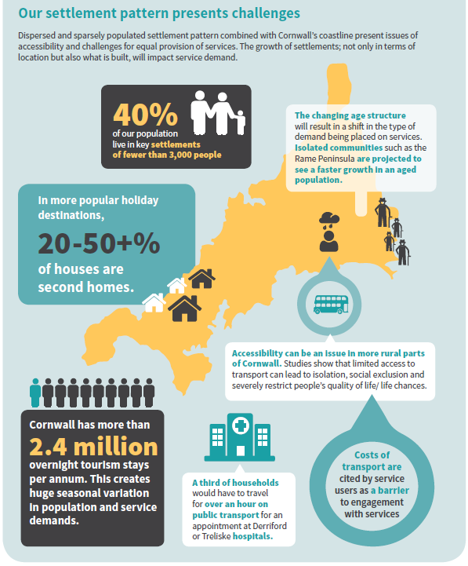
3.CORNWALL STATISTICS/ BARRIERS
While Cornwall benefits from 697km of coastline, over 40% of the population lives in settlements of less than 3,000 people.

Accessing health and social care services therefore has its complexities.

From public transport and road conditions, accessibility and rurality to increases in overnight tourism (Cornwall has more than 2.4 million overnight tourism stays per annum) the pressure on service providers has never been higher.

4.RESOURCES FOR ENGAGEMENT

4.1 Volunteers

We currently have 11 active volunteers, with many committing significant time to support our outreach and engagement. We have had three volunteer resignations, due to health and other volunteering commitments. However, one of our long standing volunteers has progressed to becoming a board member and we have had five new volunteer sign-up’s, one of which is a young student. We also have a volunteer who has been helping us with our End Of Life research, and has made the decision to become a volunteer with us. Along with our current volunteers, the new additions to our volunteer team will be able to support regular drop-ins as well as new outreach opportunities.

We have run training sessions to help volunteers keep abreast of changes to the health and social care sector as well as our internal processes and structure changes.

  - Volunteer Resources

To support the volunteers we run regular Healthwatch Cornwall Advisory Forums (HCAF), giving the volunteers an opportunity to discuss any concerns, and meet up to hear what we
are working on and any current issues, who our target audiences are and help to steer our work for the future.

In recent months we have been able to close the feedback loop, following on from Patient Experience Group (PEG) meetings at Royal Cornwall Hospital Trust (RCHT). This has meant that we are able to provide more information to our volunteers about what action has been taken and consequently changes made.

To help the volunteers we also provide them with a suitcase containing promotional materials that they can use at any outreach events they attend. They also have a library of useful resources and documents to use.
This includes the;
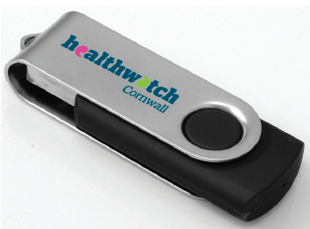
- Have Your Say (HYS) Form
- Newsletter sign-up sheets
- Data recording forms
- Presentations
- HC strategy information
- Volunteer expenses forms and policies
- Facilitation support documents
- NHS Information (Structure, stats etc.)
- Pop-up banners (New banners have been sourced and provided)
- Sign Posting leaflets (Newly collated signposting information)

We have provided all of the volunteers their own USB stick and the forms are continually updated. All the documents in the library can be found here: W:\Healthwatch\EVENTSandOUTREACH\Library

  - Drop In Recording Form

A recording sheet was created to highlight on our events spread-sheet simple figures, for example the number of HYS forms that are collected at each event, how many signed up to the newsletter and any comments or signposting we have provided. This form is also used by the volunteers to record this data and is returned with their HYS forms. This is then recorded in the events spread-sheet to give us up to date and current data we can extract quickly and easily. This continues to be used for the audit trail and has been updated this year to include which clinics with which consultant are taking place within which hospital trust.

This data also helps us review where we are receiving most of our feedback from, and to help us when planning future events.

  - Have your Say

In June 2018 a training session reviewing the current HYS form and diversity information took place. This interactive session reviewed the form and advised volunteers on the impact of the Civi-CRM and how this relates to specific data recording. ( We have made some changes to the form, in that we have removed the question asking if people are aware of Shaping Our Future)

This allowed the volunteers to ‘have their say’ and feed into the work we do. It also highlighted the need for stringent processes in regard to recording data and making data work for us in our reporting structures. We continue to provide regular training on Have Your Say’s to ensure information remains at the forefront of our volunteers thoughts. The training session presentation and documents can be found here: W:\Healthwatch\EVENTSandOUTREACH\Library\HYS Workshop

  - Corporate Presentation

One concern highlighted by volunteers was their confidence in representing HC at local events. An easy to use presentation was created for use by anyone representing HC at talks, events or even for increasing and raising awareness. Notes are continually added to make the presentation more interactive. For example this year a play your cards right bolt on was devised which is so helpful to engage large groups of people.

This was presented to the volunteers at the training session in June 2018 and is used currently for inducting new staff members and volunteers. It is updated regularly and new versions are emailed to the volunteers for them to use. The Presentation can be found here: W:\Healthwatch\EVENTSandOUTREACH\Library\Presentations

  - Newsletter Sign-up

At each event we encourage interested parties to sign-up to our monthly newsletter, allowing them to receive regular updates in regards to the work we are doing. This is an effective way of sharing our success stories and information about local services.

We have contacted people that have signed up for our newsletter and updated our processes to incorporate the new GDPR regulations.

  - Spread-sheet

All events are recorded in our Events and Outreach spread-sheet for the year. This information is used ad-hoc for general information as well as quarterly to feed-in to our performance report and yearly to populate our annual review on events and outreach.
The information we record includes:
- Who from outreach is leading on a particular event
- General information about the event: date, time, contact name, organisation etc.
- Who is attending from HC Staff and Volunteers
- Data from feedback; how many engaged with, how many aware of STP, how many HYS/Surveys/ Newsletter sign-ups
- Items needed/activities
- Interest in becoming a volunteer
- Any signposting: SEAP/PALS
- Further comments/ general feedback from the event
- Success of event/ useful comments

This information allows us to review successful events and when looking at planning future events, enables us to keep in contact with potential stake-holders etc.

It also gives access for anyone in the team to review the spread-sheet and have all the information to hand. For example anyone from HC can access the data if the outreach team are unavailable, to answer any questions or see who to refer to as leading on that event. The spread-sheet is saved under each year:..\HC Outreach and Event recording 2018-19.xlsx

  - Sign Posting Spread-sheet

This document has been created for an easy reference of organisations which we regularly signpost people to. Staff both on outreach and in the office as well as volunteers have a copy of or access to this useful information.

- WORK UNDERTAKEN/ PROJECTS

  - Hospital Drop-In’s

Healthwatch Cornwall continues to attend regular hospital Drop-In’s across the county, which provides a clear correlation to health services by patients, visitors and staff. This also enables us to have a consistent presence whilst receiving regular feedback. The Hospital Drop-In’s are held in the minor injury units across Cornwall and at both Acute Hospitals used by Cornish patients. These hospitals are run by three different NHS trusts.

In addition to the regular sessions we ran in 2017-2018, we have re-established drop-in’s at Newquay, Falmouth, Hayle and Helston and diversified into GP surgeries, family hub’s and libraries.

We have also identified themes and trends in certain areas of RCHT, so have carried out some more focused work in these areas (Opthamology, Cardiac and Maternity) in order to feed this back to the PEG, with a view to achieving an improvement in how these services are delivered.

  - Community Events

We have attended and supported a number of community events including those run by local service providers and support organisations. We run these events to engage with a diverse mix of people across the county, to gather feedback and to raise our profile and awareness to the public.

This year we yet again supported Play Fest. This is a large scale event which was held at Truro Cattle Market. It attracts on average 5,000 attendees over two days in August and is a great event to engage with families and young people. This year a new activity was created; a Feel Wheel – This is an activity that children over the age of 5 can create using a wheel and emoji’s to express how they might feel and coping mechanisms. This was extremely well received by everyone. You can find a copy of it here. The children and adults really liked it and teachers and nurses asked to take copies back to use in their places of work.

Some other events we have supported this year have included:
- Health and Wellbeing Fairs - Tregolls Lodge Resident’s club
- SWASFT Lets talk Drop-in Session - Sexual Health Population and Prevention
- Festival of Health - The Royal Cornwall Show
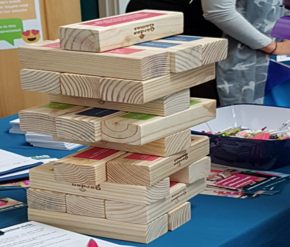
- Healthwatch Cornwall’s EOL Conference - Health Information Week - People Helping people event - Healthy Living in your Community
Various Freshers Fairs; A “Healthy Jenga” was devised which was aimed at young people by using labels on the bricks of health statistics including sexual health, smoking and drinking. This activity was also received extremely well.

Following on from a Cornwall Council public engagement and consultation with regards to adult social care charging policies. Healthwatch Cornwall conducted a lessons learnt exercise involving public engagement. A report was produced “No Changes About me without me” The link can be found here: https://www.healthwatchcornwall.co.uk/wp-content/uploads/2018/10/20181010-Final-ASC-Consultation-report-low-res.pdf

5.3 Support Groups

Supporting local health related groups we have presented to members at various venues across the county. Some organisations we have worked with have included:

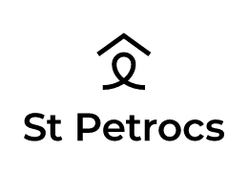

  - Professional Network

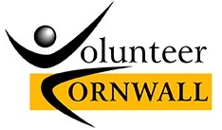
A large part of the outreach team’s role, is to identify and attend local events and get involved in local communities. We do this by networking and looking for opportunities for collaborative working. Some of the organisations we have been involved with in the past financial year include:

5.5 Royal Cornwall Hospital Treliske Visiting Times

Kim O’Keeffe Chief Nurse and Frazer Underwood Assistant Chief Nurse asked HC to comment on the draft policy, which is a proposed move to ‘Open Visiting’ at RCHT. The aim was to move from fixed visiting times to open visiting on appropriate wards, in line with many other trusts nationally, where this approach has generally been well received by patients, family and staff. A focused piece of work was carried out at RCH Treliske to ascertain whether patients and staff felt that open ended visiting times would be beneficial.

Any changes to visiting hours following this consultation will be made available publically and you can check by phoning the hospital switchboard on: 01872 250000 or through the website: www.royalcornwall.nhs.uk/ward.

5.6 Care Opinion Pilot

Healthwatch Cornwall’s Outreach and Engagement team has been working with Royal Cornwall Hospital’s NHS Trust to help facilitate their patient and staff access to a public website called Care Opinion. Care Opinion is independent of the NHS and was set up to enable people to share their experiences (stories) of health and social care services on its public website in a safe and simple way. Good and bad stories can be submitted to the site and once received will be shared with relevant service providers by Care Opinion to elicit response. Stories to the website are anonymised, with no personal details shared but the stories provided are open to the public to see.

In order to help Royal Cornwall Hospital’s Trust with this initiative, Healthwatch Cornwall will now, when holding ‘Have Your Say’ conversations, invite patients, the public and staff members whose main experience centres on care and treatment at one of the Royal Cornwall’s hospitals, to share their story with Care Opinion.

The Have Your Say Form has been amended to incorporate a new section on Care Opinion with other minor tweaks to the main body of the form to ensure we have the necessary data to complete the steps required when submitting a story to the Care Opinion site.

5.7 Outreach and Engagement Statistics

Throughout the financial year stats have been recorded on the events we have attended and the outcomes we have had. Here are some of the stats we have from those:

Over the past year we have attended 146 outreach events including hospital drop-ins, community events and talks, helping us raise awareness and gather feedback from attendees.

Attending the outreach events and meetings we have engaged with 2,325 people, raising awareness of Healthwatch Cornwall during the financial year 2018/19

We have taken 521 ‘Have your Say’ forms – gathering vital feedback on health and social care services in Cornwall.

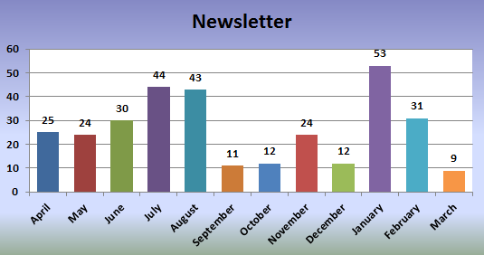

We’ve had 168 people sign up to our monthly newsletter; ensuring we can keep in touch with local people about our work and the work going on in health and social care services across the county.

Although statistics of leaflets/number’s engaged with and Have Your Says have decreased slightly, we have carried out more focused pieces of work this year including survey’s for wifi, extended visiting hours, Adult Social Care alongside engagement based in Opthamology, Cardiac and Postnatal.

At the outreach events we have been keen to raise awareness of Cornwall’s Sustainability and Transformation Partnership work – otherwise known as Shaping our Future (SoF). As such, we have been asking those that we engage with, if they had heard of the work going on.

Shockingly only 5% of people surveyed, knew of SoF. As such we have fed back to the Shaping our Future Team, the need for more improved marketing and communication around this.

- PARTNERSHIPS/ JOINT WORKING
  - Healthwatch Plymouth

As part of the national framework of Healthwatch, our closest counterparts (Isles of Scilly and Plymouth) our close allies, when it comes to challenging or addressing any concerns that affect residents in both Cornwall and Devon. In regards to a large number of East Cornwall residents, often using Derriford Hospital in Plymouth, as their main acute hospital. It made sense to join forces with Healthwatch Plymouth in gathering data from the hospital. So since August 2017 we have run joint sessions at the hospital and both parties refer residents of either area to the corresponding Healthwatch.
This has worked extremely well and as such we have built up a good working relationship which benefits both parties.
We have also invited Healthwatch Plymouth to our offices to talk about further collaboration and we are in close contact about anything that they may be interested in or working on.

  - Patient Experience Groups/ PALS/ Hospital Trusts

Meeting the Patient Experience teams has been useful in regards to sharing data, feedback and concerns. We have built very effective working relationships with Royal Cornwall Hospital Trust and are looking to improve relationships with Cornwall Foundation Primary Trust and University Hospitals Plymouth Trust teams . We meet regularly and attend the Patient Experience Group Meetings at Treliske (RCHT) , Patient Experience Committee at Derriford, and the Patient Reference Group for CFT.
Natalie Swann, our Research Manager also reports back directly to each trust and PALS team, any concerns or useful feedback we receive.

  - Interagency Work

The Outreach team attend local interagency meetings across the county – these are run by Cornwall Foundation Trust’s Social Inclusion team. A number of organisations attend giving a wealth of information about the services available across the county and is useful for signposting to our audiences. Examples of organisations represented include:

6.4 SWASFT
Following on from attending the Healthwtch and SWASFT engagement day Healthwatch Cornwall continue to work jointly with SWASFT. HC have supported SWASFT at their “Lets Talk” Drop-In Sessions and have also dialled into their continuous improvement group meetings.

- RECOMMENDATIONS
It has been a busy year with lots of outreach and engagement opportunities. It has always been a challenge to ensure we can gather feedback from across the county on all health and social care services. We have tried to ensure a diverse mix of attendance at regular drop-ins, small, medium and large scale events as well as attending local talks and health related community days.
We have many ideas to increase our engagement and outreach activities and we remain committed to gathering feedback from all sectors. Following on from trying to expand our outreach in 2017/2018. We now have a young health and social care student volunteering for HC. She has been attending Drop-Ins and events. She is also keen to shadow meetings to experience scrutiny of quality, safety and general governance within the sector. Her work is being documented as a slide show which can be shared across all social media platforms. We hope to introduce College Drop-in’s and from this, to develop a group of young people to gather feedback on young people’s experience of health and social care services in Cornwall. This will help to ensure services are accessible and up to standard.

Some other ideas are:
- Housing/ Housing Associations - Food Banks - One Stop Shops - Supermarkets
- Care/ Residential Homes - Farmers Markets - Car Boot Sales - PPGs
- Other health Support Groups - Job Centres (offered by DWP) - Libraries
- Other large employers - NHS Staff Meetings at various sites/ hospitals etc.
- Social Care/ Domiciliary care Employees - Local community based outreach i.e. cafes

This will help us to target specific audiences, to ensure our feedback and data is as far reaching across Cornwall, as possible.

Annex 1 - PESTEL ANALYSIS

Political
- Policies and Procedures
- Inter-agency working – SLAs, Policy
- Hospital Trusts (RCHT/CFT)
- Brexit Impact – staffing levels
- Community – MPs/ Councillors/ Council
- Political Impact of Uncertainty
- Spending Reductions
- European Funding

Economic
- Economic Impact of Brexit
- Partnerships - availability/ funding/ expertise/ buy-in
- Growth – Sustainability/ impact/ drivers
- Demand vs. Supply (lack of resources)

Social (Demographics)
- Equality strands – Religion/ Age/ Race / Disability/ LGBT impacts/ diversity/ lone parents/ carers
- Location – Rural/ Transport/ Tourism impact
- Availability – carers/ disabilities/ hard to reach/ over-engaged
- Perceptions and Attitude – Status Quo/ Where does feedback go/ impact
- Growth – push in Cornwall/ Value / Credibility/ Diversity/ County-wide
- Sustainability – 3-year contract/ raising awareness / making an impact/ marketing/ success/ looking forward

Technical
- Internet – training/ availability/ access/ costs
- Mobile Apps – other tools (SEO, CMS systems/ Social Media)
- Capacity – needs/gap analysis/ right level/ support/ knowledge/ Training
- Research and Development – relevance/ impact/ review/ buy-in/ outcomes
- Approach – Partnerships/ Objectives/ Clear goals/ Collaborative working
- Systems – measuring outcomes/ Research/ Evidence/ impact assessment

Environmental
- Sustainability
- Impact on Carbon Footprint – transport/ waste/ fuel
- Rural – geography/ meeting needs/ wants

Legal
- Health and Safety – Insurance/ Protection/ Risk Assessments/ Public Liability
- Data Law – data protection/ GDPR/ privacy laws
- Safeguarding/ Protection/ Clear Policies
- Health and Social Care Act
- Governance – use of funding/ reporting/ procedures

Annex 2 - SWOT ANALYSIS

Strengths  - Good Brand/ Reputation/ Credibility  - Access to market – newsletter/ reports/ drop-In’s/ outreach  - Strong existing relationships with stakeholders/ external agencies – Hospital Trusts/ Patient Experience/ Commissioners/ Local and National Healthwatch/ Government  - Diverse knowledge base in-house / can call upon  - Not for Profit  - Our Independence  - Contract Renewal  - Enhanced Profile  - Team Collaboration and relationships  - ODAG and wellbeing | Weaknesses  - Changing Framework – staffing changes/ restructure  - Extraction of data delays (CRM)  - Prioritisation – going forward to use assessment wheel and matrix  - Over Commitment
Opportunities  - Enhance upon relationships with existing agencies  - Building new partnerships  - CRM Reporting Improvement  - CEO impact in making external influence/ impact/ giving direction  - Showcasing Success / Case Studies  - Business Knowledge improvement  - Training Courses  - New Projects  - Collaboration with other Healthwatch’s and Healthwatch  England  - Other organisations joining us (MVP)  - Media (Radio and TV) | Threats  - Time restraints  - Lack of funding impact  - Pace and Complexity of NHS and changing environment/ SoF/ACS  - Growth and sustainability  - Lack of buy-in/ support/ over engaged  - Brexit and political implications  - Rural barriers – transport/ reaching customers/ hard to reach

