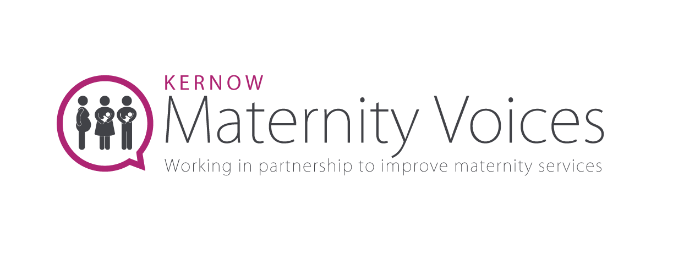

Pelvic health volunteer role description
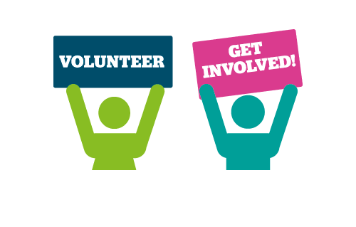
Kernow Maternity Voices Partnership is looking for enthusiastic volunteers to get involved with our specific work around perinatal pelvic health.

As a volunteer you will be expected to:
- Work collaboratively with other perinatal pelvic health volunteers
- Regularly engage with your local community to gather the voices of those who have used maternity services
- Share your experiences as a case study illustrating the importance of pelvic health services
- Lead on perinatal pelvic health projects, working with maternity healthcare professionals
- Support the Chair to champion service user involvement in the design of services
- Flag urgent and concerning issues to the Chair
- Support the social media volunteer with content to promote the activities and achievements of the Kernow MVP
- Actively support engagement activities such as Facebook live events, newsletters, online focus groups and community engagement
- Provide feedback to the committee about your project and feedback themes

Personal Qualities and Skills we are looking for are:
- Have personal experience of pelvic health concerns and/or perineal trauma during pregnancy, birth or perinatally
- Friendly, professional, and approachable
- Digital access and ability to use Microsoft teams, social media and email
- Excellent communication and writing skills and can adapt style and tone for specific audiences
- Ability to work independently and use own initiative
- Able to deal with confidential information sensitively
- Actively challenge discrimination and be committed to supporting inclusive and accessible services for all pregnant people and families
- Can commit to at least 12 months of volunteering

Time commitment: These roles are flexible, but it is anticipated that there would be approximately a day of volunteering each week. There is an expectation that you would regularly check and reply to emails in relation to this project throughout the working week and attend regular perinatal pelvic health meetings, usually on a Tuesday. It is expected that there will be a minimum of 2 hours of meetings per month. Plus, there is the need to engage with the community, support feedback collection and network with other Kernow MVP volunteers. As a Kernow MVP volunteer you will need to keep up to date with maternity service changes at a local, regional, and national level. If some or all of the elements of these volunteer roles appeal to you, please get in touch to discuss the opportunities.

What will you get out of volunteering?
We understand that everyone has different motivations for volunteering but here are some of the possible benefits for getting involved:
- Help people share their experiences and be a part of helping to facilitate positive change across maternity services here in Cornwall
- Access to training, conferences and networking events
- Use your voice and advocate for others to improve perinatal pelvic health services in your community
- Coproduce vital service improvements and care pathways that benefit all pregnant people in Cornwall and Isles of Scilly
- Build your confidence and communication skills

Location
These will be remote roles, so access to a computer, tablet, or phone with internet access is essential. Once face to face meetings can occur again, attending the Kernow MVP committee meetings and other meetings at Royal Cornwall Hospital, Truro would be needed.

Recruitment Method
Application form, DBS, informal interview, induction, and trial period.

Ongoing support
Regular catch ups, open conversations, and collaboration with MVP chair, Healthwatch staff and other volunteers.

