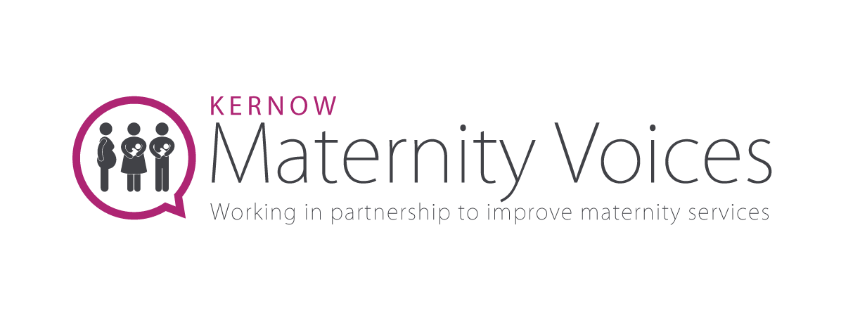

MVP Engagement Volunteer Role Description

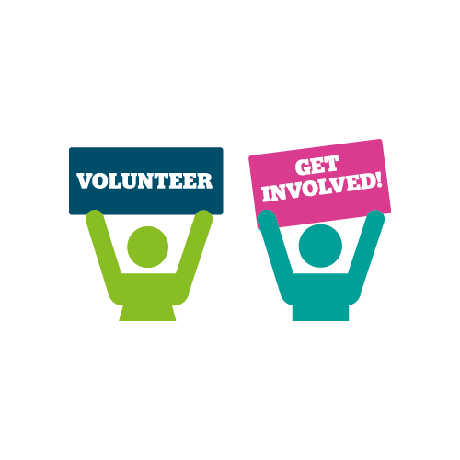
Kernow Maternity Voices Partnership is looking for diverse and passionate individuals, both service users and professionals to volunteer their time to gather feedback from our communities on their experiences of maternity services in Cornwall. This includes helping to engage people using online platforms such as Zoom, Microsoft Teams and Facebook Live events. When it is covid safe engagement activities will include being out and about in the community at events, groups and centres.

As a volunteer you could support with:
- Engaging with women, their partners and families and encourage them to feedback about their experience of the maternity services
- Plan and facilitate specific engagement activities
- Connect with and attend groups that represent a specific community in Cornwall
- Represent Kernow Maternity at community events or meetings
- Provide regular feedback to Kernow Maternity Voices.

Personal Qualities and Skills we are looking for are;

- Listening to the voices of Women & Families
- Sharing Kernow Maternity Voices mission with others
- Having good empathy and identifying with other people’s feelings
- Being anti-racist and committed to supporting inclusive and accessible services
- Excellent communication and writing skills and can adapt style and tone for specific audiences
- Dealing with confidential information sensitively and appropriately
- Adheres to MVP and Healthwatch values, policies and procedures
- Digital access and ability to use Microsoft teams, social media and email
- Attending occasional meetings and training sessions to share feedback and ideas
- Can commit to at least 6 months of volunteering

What will you get out of volunteering?
We understand that everyone has different motivations for volunteering but here are some of the possible benefits for getting involved.
- Help people share their experiences and be a part of helping to facilitate positive change across Maternity services here in Cornwall.
- Have a voice on the issues affecting maternity services for people in your community
- Build your confidence and communication skills
- Be a part of a great group of volunteers and have fun!

Training and Development
The Kernow Maternity Voices Chair and Vice chair and Volunteer Officer at Healthwatch Cornwall will support you to fulfil and feel confident in the role of Engagement Volunteer by providing:

- Volunteer Induction
- Access to Council Learning Hub
- Relevant resources and tools to use
- Healthwatch Cornwall in-house training
- Access to other relevant external courses/conferences
- On-going support/liaison

Location
This role will be online / remote involvement until it is Covid safe to return to being community based. Then we will attend several different settings within the community, for example hospitals, family centres, and community venues.

Expenses
Kernow Maternity Voices will pay reasonable travelling expenses – please see separate Volunteer Expenses Policy for further details.
Recruitment Method
Informal Interview, DBS, Mandatory training, Induction and Trial Period.

All these arrangements are binding in honour only and not intended to be legally binding as this is a voluntary role. The involvement of all parties is based on good will and trust.

