What people have told us about NHS dentistry
A review of our evidence: January to March 2021

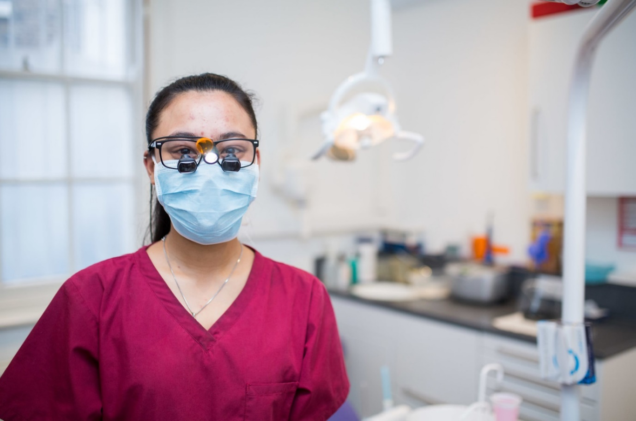

Contents
Background 3
Key findings 4
Call to action 5
Public sentiment 5
Unequal access 7
Poor and incorrect information 8
Problems getting urgent care 9
Pressure to go private 10
Long waiting times 12
Removal from lists 13
Poor experience during COVID-19 13
Impact on individuals 14
Public attitudes to NHS dental care as we emerge from COVID-19 16
Our recommendations 24

Background
Dentistry is a recurring issue for Healthwatch since it was set up in 2013. However, since the start of lockdown in March 2020, we have noticed a sharp increase in the number of people telling us about not being able to access timely NHS dental care. ​
In December 2020, we published a report on the impact of COVID-19 on NHS dentistry following a 452% rise in calls and complaints to local Healthwatch between July - Sept 2020. It was based on the experiences of 1,313 people who were trying to access NHS dental services during that period. ​
As public concerns continued, we looked at a further 1,129 people’s experiences of accessing dental care between Oct - Dec 2020, and published a follow-up review to warn about the ongoing dentistry crisis. ​
Our findings were widely publicised by the media and referenced in a parliamentary debate.
Our latest findings show many issues we have reported before continued; explores in more depth people’s attitudes towards affording NHS dental care; and sets out recommendations to create equal and affordable access to NHS dentistry.

Key findings
- Access to NHS dentistry remained a key issue for people across England between January and March 2021. Some people were being asked to wait up to three years to get an NHS appointment; however, private appointments are available within a week. Delays in access have resulted in worsening of painful symptoms and have even led to hospitalisation after an overdose of painkillers. ​
- People have felt pressured to pay for private care as some dentists were offering only private appointments. Our polling data suggests that almost 1 in 3 (31%) had to pay private fees to get all the treatment they needed and nearly 2 in 5 (39%) have reported that they have been charged extra for their NHS treatments and to cover for the costs of PPE. ​
- Generally, people found NHS dental treatment charges expensive, especially those from lower income groups. Over 55s from minority ethnic backgrounds and on low incomes were six times as likely to avoid dental treatments than their White counterparts because they cannot afford the costs. ​
- There were re regional variations in people’s experiences of accessing NHS dentistry – people in the North East are at greater disadvantage than in any other part of the country. People over 65 from this region are at a greater risk of avoiding dental treatment due to affordability issues. ​
- Although people were wary of catching COVID-19 during their dental appointment, most felt safe when they have attended one. ​

Call to action
It is vital that the Government acts on these findings and reforms dentistry as a matter of urgency to create equal and affordable access to care.

Public sentiment
Between January – March 2021, we have again seen an increase in the number of people who have spoken to us about dentistry. During this period, 1,375 people shared their experiences of accessing NHS dental care – this is 22% higher when compared with the previous three months. The proportion of feedback related to dentistry remains consistently high as seen in the previous six months.

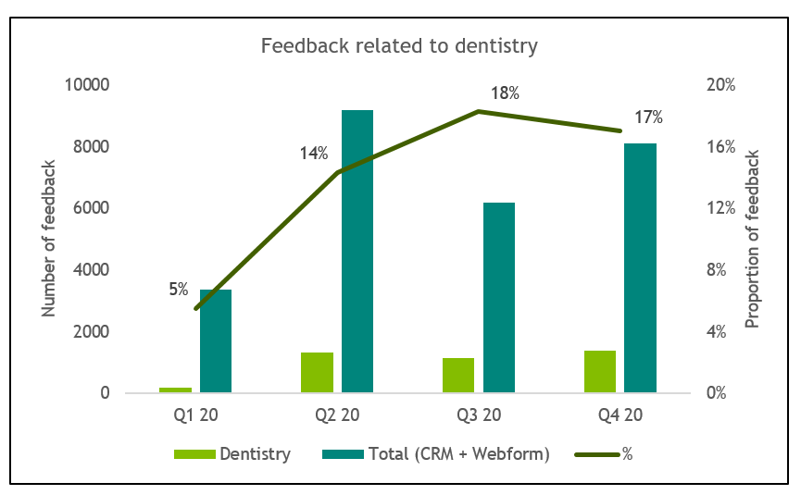

​

Negative sentiment in feedback to dentistry was at record low in the last quarter. Nearly 3 in 5 people (59%) reported a negative experience between January – March 2021, however, only 1 in 30 (3%) reported a positive one. This is a sharp decrease when compared with the previous quarter when more than 1 in 10 (12%) had told us about a positive dental care experience between October – December 2020.
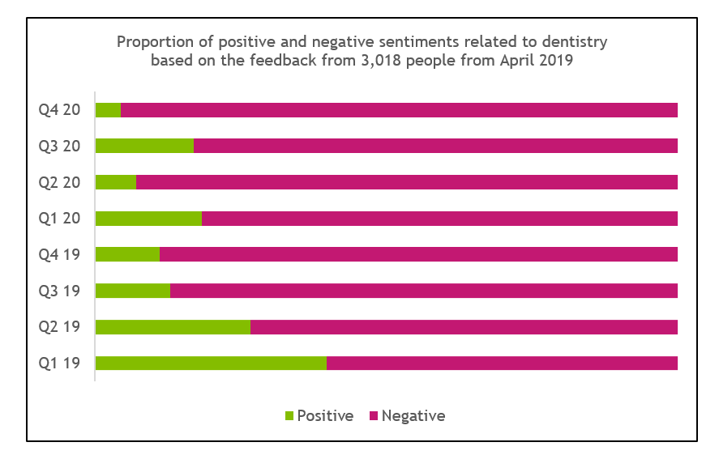
​

Unequal access:
- Access to NHS dentistry continues to be the biggest issue for most people who spoke to us – on average, 4 in 5 people (80%) found it difficult to access timely care between January - March 2021. In fact, access has consistently become more difficult over the last five months.
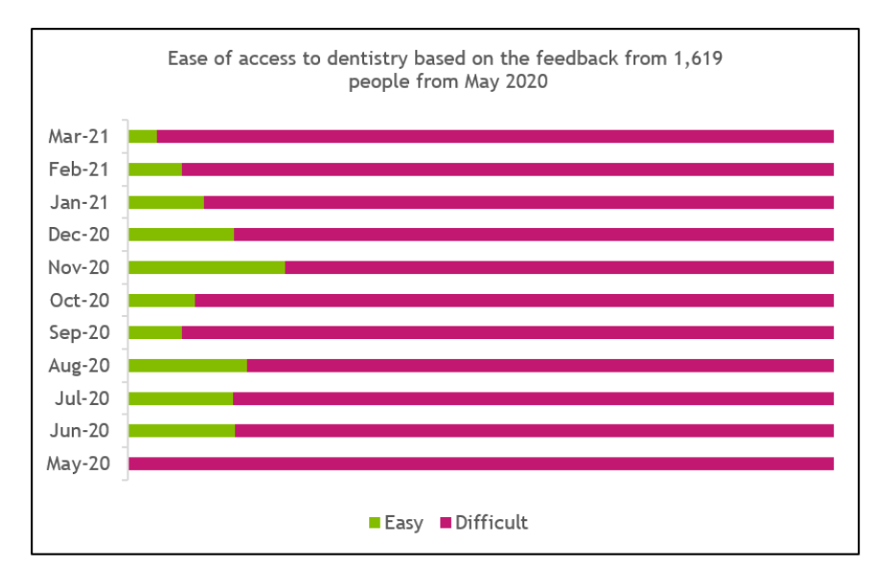

- Healthwatch Harrow reported that people from Black, Asian and minority ethnic communities have been disproportionately affected in accessing services, including dental services, during the pandemic. They also are less likely to have a regular NHS dentist and more likely to struggle accessing one when they have pain or problems. We’ve also heard from asylum seekers in dental pain who were unable to get any help from the services. ​
- Lack of NHS appointments meant that pregnant women were unable to take advantage of free dental care during maternity, which caused frustrations. As they were on maternity leave, they couldn’t afford to pay privately either. Many contacted their Healthwatch in desperation when they couldn’t find a dentist. ​
“A client is having great difficulty registering with an NHS dentist. They are 24 weeks pregnant and have a broken and infected tooth. They have tried to register with many dentists in Watford but have been rejected by all of them, they therefore contacted us to ask how they could get help with this situation.”
Healthwatch Hertfordshire, 31 March 2021
- Some parents couldn’t access timely care for their young children, including babies who are teething. ​

Poor and incorrect information

Lack of information
Several local Healthwatch reported that often people contacted them because they didn’t know which NHS dentists had started to do routine check-ups and/or if any were taking on new patients. When appointments were cancelled during the lockdown, practices didn’t always offer another date – this left people unsure about when they might get to see their dentist again. ​

Incorrect information
People have been given incorrect information about treatment costs or entitlement to reduced cost treatment. They were told they could claim the treatment charges as they were on Universal Credit, in some cases, their claim was later rejected, and they were charged a private fee. This is consistent with our findings from the feedback we had received before the pandemic - people often feel confused about such entitlements and end up paying more than they can afford or being penalised for claiming free treatments in error.

Problems getting urgent care
- Access to urgent dental care remained an ongoing issue – while some didn’t know how to access urgent services, others couldn’t get treatment as either practices didn’t have any urgent appointments left or the phone lines for Urgent Dental Care hubs were constantly busy. People on pay-as-you-go phone contracts found it particularly difficult when they were put on hold for over an hour only to be told to call back again next day. ​
“Trying to get an emergency dental appointment has been a nightmare. The number you’re told to ring answers straight away but then puts you on hold, listening to music, I was waiting for 95 mins solid using my landline and mobile. After eventually getting through was told no appointments were available and to ring the following day and go through the same scenario. I think this is absolutely ridiculous that they keep you on hold for this long and paying for the call.” Healthwatch England, 18 January 2021
- People have been asked to wait for up to six weeks to get an emergency appointment.
- Healthwatch Newham carried out research to determine levels of access to emergency dental care and options during COVID-19 – they found that more than 9 in 10 (93%) dental practices in Newham had limited NHS emergency appointment capacity and were not seeing new walk-in patients. Similar numbers said that they could not offer appointments to new NHS patients because of the COVID-19 backlog. Fewer than 1 in 5 (16%) were offering a private emergency appointment due to pressures on their services.

Pressure to go private
- Dentists appearing to prioritise private care: people have felt pressured to go private as dentists said that they couldn’t provide NHS treatments but were able to if people were willing to pay private fees. This was especially difficult for those on low incomes, those who lost their jobs during the pandemic, and for people who were faced with having to afford private care for their whole family because they did not have a regular NHS dentist. People have borrowed money to pay for private treatments as a last resort.​
“I have had a problem as I lost a filling, and now the tooth has broken off completely. Although not in pain, it’s making it difficult for me to eat. My dental practice has told me that they only have appointments for serious cases. However, the same practice is sending me emails encouraging me to pay for private treatments.” Healthwatch Bristol, March 2021
- Healthwatch North Yorkshire found that there is a growing frustration among people at a perceived two-tier dental system between private and NHS patients. Whilst they heard about regular appointments being cancelled for NHS patients, callers told them that private appointments were still going ahead. ​
- People have been asked to pay additional dental charges to cover for the costs of PPE and cleaning of the premises. Many didn’t realise that dentists cannot charge for PPE for NHS work and paid the extra amount. This shows that patients are not always clear about what is and isn’t “NHS”. ​

Dental practices shutting down or going completely private:
- Healthwatch Wandsworth spoke to over a third of all their local practices and found that more than 2 in 5 (42%) were for private patients only. This leaves many with no choice as there aren’t other practices nearby who are taking on new NHS patients and they are unable to afford private dentistry. When dentists leave with no replacements, access to care becomes harder for people living in remote parts of the country, as described below: ​
“My dentist went back to Bulgaria in 2016 and ever since no dentist has been willing to take me as a new patient on the Isle of Wight. The results are 3 teeth almost missing, 2 other chipped and constant pain with several abscesses. It’s getting hard to chew and even to speak as I am missing a front tooth. I don’t have the means to go private which is the only option offered to me! It’s scandalous.”
Healthwatch England, 2 March 2021

Long waiting times:
- People are being asked to wait anywhere between a few months to three years to get an NHS appointment – some can’t even get on a waiting list. Patients said that they were unable to get an appointment after regularly calling multiple practices for weeks and months to check for availability and we’ve heard from practices about having thousands of patients on their waiting lists and very limited resources to manage the workload. ​
“I work for a mixed NHS and private dental practice. We have in excess of 8,000 patients and only 2 dentists, the waiting list for NHS dentist is years and we have so many enquiries every day and unable to help. The emergency dental helpline do not offer patients without a dentist the care they need – it really needs to be looked at.”
Healthwatch Cornwall, 10 March 2021

Removals from lists
- People being removed from practice lists: people were unable to make an appointment with their regular dental practice because they were removed from the practice list for not making an appointment sooner. They only became aware of this when they tried to book an appointment as they had never received any notification about it. Some were unable to find another practice taking new NHS patients, so they ended up paying privately to be able to see a dentist.

Poor experience during COVID-19
- COVID-19 safety measures were not strictly followed: some people did not feel safe when attending their appointments. When dentists did not wear a face shield, for example, it made them apprehensive about getting infected during their visit. Safety concerns have also meant that some have been reluctant to attend an appointment. ​
- In other cases, practices did not consider how their COVID-19 safety measures would impact the patients. For example, some people were asked to wait outside in bitterly cold weather. People couldn’t use the toilets as they were locked due to safety concerns – this was particularly difficult for those who lived far away from their practice.
- Provision of domiciliary dental care hasn’t been resumed by many dental practices, due to COVID-19 restrictions. As a result, some disabled people are unable to access the care they need. Those needing British Sign Language (BSL) interpreters couldn’t get treatment for lack of adequate interpretation services at the practice. An individual with sign-language needs left an appointment in tears when they couldn’t understand the dentist’s written instructions - they did not have the English skills to understand what was being said to them. ​
Impact on Individuals

Pain and discomfort
- Consequences of delayed access meant that people had to put up with pain, swellings, broken teeth, fillings and dentures or they were unable to get any preventative care leading to worsening of their dental problems and losing their teeth. Some were only offered antibiotics to control their symptoms which provided temporary relief but later led to reinfections. One individual ended up in a hospital after overdosing them self on painkillers: ​
“I have been trying to get a dentist for three years, last week I ended up in hospital for three days because I had severe pain and could not find a dentist for emergencies or otherwise to fix my teeth. I ended up taking too many paracetamol and had to go to A&E on the advice of [NHS]111. I ended up on a drip for 36 hours and have finally come home. I still do not have a dentist and I am still in pain.”
Healthwatch Suffolk, 12/03/21]

Reliance on painkillers and antibiotics:
- When practices couldn’t provide appointments, they advised people to take painkillers or buy temporary filling kits and treat themselves. This wasn’t always helpful as the fillings kept dislodging frequently, resulting in people spending more money in buying replacements. Moreover, older people reported that they could not even use the kits as they had poor eyesight – it seems practices did not consider individual circumstances when giving such advice. ​
- People either struggled to access antibiotics despite having a visible swelling as they couldn’t get a dentist appointment and their GP wasn’t able to prescribe because it was a dental problem, or they were repeatedly asked to take antibiotics without resolving the underlying issue. People are increasingly being prescribed antibiotics over the phone by practices or by NHS 111 with no provision for a follow-up appointment to get treated. Repeated use of antibiotics can make individuals resistant to the drug which can have implications on their future health.

Public attitudes to NHS dental care as we emerge from COVID-19 – an online poll
In February 2021, we commissioned an online poll to find out how the cost issues impact different groups of people, in particular those from minority ethnic communities. The survey also looked at people’s experiences of accessing NHS dentistry during the pandemic and how it has impacted their future habits. ​

An online poll was carried out by Yonder Data Solutions for HWE from February 19 – 25, 2021, which received responses from 2,019 adults (aged 18+) based in England.​

Public views on NHS dental treatment charges
- Most people find NHS dental treatment charges expensive with socio-economic grade strongly influencing affordability - more than 3 in 5 people (61%) feel that NHS dental treatment charges are expensive and 3 in 11 (27%) either struggle to pay or avoid any dental treatment because they cannot afford the costs. While nearly 7 in 10 (69%) from higher socio-economic grade (SEG) A either don’t find NHS charges expensive or can afford to pay the costs, only 3 in 8 (38%) from lower grades DE feel the same. In fact, while only 6% of SEG-AB respondents avoid treatment due to affordability issues, it’s exactly double for those in DE grade at 12%.​
- People who feel that the treatment charges are unfair are less likely to book a dentist appointment – over 1 in 2 (52%) people feel that the charges are fair, however, 3 in 9 (33%) feel they are unfair. More than 2 in 5 people (44%) who did not see a dentist over the last year feel that the charges are unfair. In comparison, 2 in 3 people (66%) who thought charges are fair, went to see a dentist. ​
- In general, people from White and Other-than-White ethnicities equally struggle to pay for NHS treatment charges – 3 in 11 (27%) people who identified themselves as White feel that they struggle to pay the costs. Similar numbers of people who do not identify as White (27%) also feel the same. People from Asian (10%), Mixed (9%) and Black (8%) ethnicities are more likely to avoid dental treatments because they can't afford the costs compared with people from White ethnicity (7%).
- Minority ethnic people from lower socio-economic grade struggle more than their White counterparts – people from minority ethnicities and DE socio-economic grade are twice as likely to avoid dental treatment because they cannot afford the costs than similar people from White background. The difference between the two groups is greater in people who are 55+ years – while 1 in 30 (3%) from White backgrounds avoid going to a dentist because they cannot pay the charges, nearly 1 in 5 (18%) from minority backgrounds do the same.
- Women find it more difficult to afford NHS dental charges than men – while 1 in 10 women (10%) avoid dental treatment because they cannot afford the costs, only 1 in 15 men (7%) do the same. As might be expected, women from lower socio-economic grades avoid treatment more than women from higher social grades (AB – 8%; C1 – 8%; C2 – 11%; DE – 13%).​
- There are regional variations in people’s ability to afford treatment charges – more than 1 in 8 people (13%) living in the North East of England avoid NHS dental treatment because of costs compared with just 1 in 30 (3%) who live in the South West. Moreover, older people (65+ years) living in the North East struggle more than those of similar age in any other parts of country - 38% of older people in the North East avoid NHS dental treatment because of costs compared with just 13% in the South East, 5% in London and 4% in Yorkshire & Humberside. Older people from the other regions do not avoid treatment because they generally can’t afford the costs.

Disparities in NHS dentistry during the pandemic
- People were less likely to have a dentist appointment during the pandemic, especially people on lower incomes and older age groups – over 3 in 5 people (61%) did not have an NHS dentist appointment since March 2020 compared with just over 1 in 3 (37%) who did. This trend is exactly the opposite of what we found in our 2020 poll when 58% of the respondents had attended an appointment in the previous two years and 39% had not. ​
- While similar proportions of people from White (37%) and Other-than-White (38%) ethnicities had an appointment, however, there was a big gap in the numbers when it came to people’s socio-economic grades. While more than 1 in 2 (51%) people from grade A had an appointment, just over 3 in 10 (31%) from grade E had one. ​
- Also, more people from over 55 age group did not have a dentist appointment compared with people who are 34 years or younger – while 29% of the former had an appointment 42% of the latter had one.
- Some people have been charged extra for the treatments and to cover the cost of PPE on the NHS – about 1 in 5 people (19%) reported they had been charged more for their treatments and the same numbers (20%) to cover for the costs of PPE when they had any dental treatment on the NHS. People in the North East have been charged the most - nearly 1 in 3 (29%) have paid extra for both their treatments and for PPE while people in the South West were charged the least – only 13% were charged extra for treatments and 17% for PPE. People from Black ethnicity have been charged more for their treatments than those from White backgrounds – nearly a quarter of Black people (24%) were charged extra compared with 1 in 7 (14%) White people. However, more White people have been charged extra for PPE (27%) than Black people (18%).
- Majority of people felt safe and reassured about infection control measures when they went to their dentist appointment – although nearly 1 in 5 people (19%) did not book an appointment because they didn’t feel safe going to a dentist during the pandemic; more than 4 in 5 people (86%) did not feel unsafe when they went to see their dentist. ​

For those who had an NHS dentist appointment:
- It was difficult to book one and many had to pay privately to access care – more than 1 in 2 people (51%) found it difficult to book an appointment and nearly 1 in 5 (17%) could not get all the treatment on the NHS. Almost 1 in 3 (31%) had to pay private fees to get all the treatment they needed. Amongst the minority ethnicities, people of Mixed heritage (56%), Black (53%) and Chinese (52%) found it slightly more difficult to book at appointment when compared with people of Asian background (49%) as well as from a White background (50%). Young Black people (under 34s) were least likely to access care privately (24%) while young Chinese people were most likely to pay private fees to access dental care (67%). ​
- It was difficult to find information about NHS appointments during the pandemic, including information about NHS dental charges – nearly 1 in 5 people (19%) found it difficult to find up to date information about NHS dentistry on practice websites or by calling NHS 111, while nearly 3 in 10 people (29%) found it difficult to find any information about NHS dental treatment charges. Men over 65 years found it nearly twice as difficult to find any information about charges than women of similar age (43% vs 22%). People living in the East Midlands found it easiest to find information about charges - fewer than 1 in 10 (9%) had difficulties- while those in the North East found it the most difficult (43% struggled to find information about NHS dental charges).​
- Many people had to put up with dental problems when they couldn’t access timely dental care – nearly 1 in 10 people (8%) could not have an NHS dentist appointment because they were either unsuccessful in booking one or couldn’t go to the dentist because they found it difficult to pay for NHS dental care. Of these, over 3 in 10 (31%) put up with the problem they had and 1 in 10 (10%) resorted to treating the problem themselves. ​

Impact of the pandemic on people’s habits of seeing a dentist ​
- The pandemic has negatively impacted on people’s willingness to see a dentist regularly – although more than 3 in 10 people (32%) would continue to see a dentist regularly just as they did before the pandemic, 1 in 4 (25%) feel that they’ll now visit only when they need to. One in 15 (6%), who did not go to a dentist regularly before, will now avoid going to the dentist as much as possible. ​
- People from minority ethnic backgrounds are less likely to see a dentist now compared with before the pandemic – 3 in 11 (27%) people from minority communities feel that they will see a dentist only when they need treatment. In comparison, fewer people from a White background (23%) feel this way. While 2 in 5 (41%) White people would continue to see their dentist regularly, just over 1 in 4 (26%) from minority communities would go to their dentist for regular check-ups. People of Asian heritage are more than twice as likely to avoid going to a dentist when compared with people from a White background (9% vs 4%).
- Young people are less likely to continue with their regular dental visits than people of older age groups – more than 1 in 2 (53%) of over 65s would continue to visit their dentist regularly following the pandemic while just under 1 in 4 (24%) of 18 – 24 year olds would do the same. ​
- Continuing the habit of visiting a dentist regularly might be impacted by where people live – fewer than 1 in 4 people (23%) in the North East would regularly visit their dentist following the pandemic compared with 2 in 5 (40%) from the South West. In London as well, only 1 in 4 (25%) would continue to visit their dentist regularly as they did before the pandemic. ​
- People from lower socio-economic grade E are more than three times more likely to rarely see a dentist as compared with people from the highest grade A (19% vs 6%) – their habit remains unchanged following the pandemic.

Our recommendations

A more rapid and radical reform of the way that dentistry is commissioned and provided​
- We have heard from both the public and from the dental profession that the current arrangements do not work. Access to NHS dental services is inconsistent and unfair, with those in the most deprived areas generally having the worst access and that needs major change to the system to rectify.​
- This has been on the agenda for some time, and during this period the situation has got worse. Although the pandemic both exacerbated and highlighted the issues, the problems were longstanding. Reform of the dental contract should be a matter of urgency. We strongly believe that if the government and the NHS fail to reform NHS dentistry provision, they risk doing long-term damage to the relationships between dentists and patients.

Use the reform of commissioning to tackle the twin crises of access and affordability ​
- For many people, there are two significant difficulties they face when needing to access NHS dental care: the availability of appointments and the ability to meet NHS charges.​
- Currently it is not possible to get a clear picture of access to dental care as lack of formal registration mean there is no oversight of which areas are under-served, and which require attention. Local Joint Strategic Needs Assessment may provide insight, but a more structured approach is required. ​
- Dental charges are often unexpected and higher band treatments can prove unaffordable for some people. The banding of charges, although apparently simple, does mean that many people face high charges. The exemptions are not clear and have led to people receiving penalty charges because they did not understand the technicalities or, in some cases, were advised wrongly. ​
- New arrangements should be based around maximising access to NHS dental services, with particular emphasis on reducing inequalities. ​

Greater clarity in the information about NHS dentistry​
- People need to know which dental practices are taking new patients, when they are restarting routine care appointments, how they can access urgent care if needed, and how much they would pay for their dental treatments. While the NHS website has information about some of these topics, we continue to hear from people about not being able to find the right information when they need it or getting inconsistent information from the providers. It clearly shows that there is a need for better information providing, especially greater transparency when it comes to charging people for their dental treatments. ​
- Also, both dental practices and patients need to be clear what it means to be ‘registered’ with an NHS dentist. People are being removed from their practice list because they haven’t seen their dentist regularly, however, there is no information about how often people should visit their dentist if they want to retain their ‘registration’. The information on NHS website about NHS dental registration conflicts with the messages people get from the practices, which suggests that providers are equally unclear about the registration policies. ​
- We reiterate what we’ve said in our previous report that the Government needs to make it a legal requirement for NHS-contracted dentists to regularly update their website and information on their practice notice boards. The NHS 111 and the NHS.UK website must be able to provide with relevant and latest information to the public.

Explore the possibilities of using dental practices to promote a broader wellbeing agenda​
- We heard during the pandemic concerns about a reduction of dentists identifying possible cancers. This highlights how dental services can support a broader health promotion agenda, particularly lifestyle issues.​
- Dental practitioners are well-placed to start conversations about healthy eating, smoking and alcohol consumption as all of these are linked to oral health.​
- With the development of primary care networks, there should be opportunities for dental care services not only to consider the oral health implications but also to refer people to appropriate services – such as weight management and smoking cessation – that may have broader health benefits.

