With the spread of Covid-19 around the UK and much of the world it can be understandably stressful if you cannot access online services like finding up to date accurate news or health information or being able to buy essential items online.

We have put together a series of guides with links to trusted websites and good quality teaching – we hope that these resources will be useful and help you to improve and learn new digital skills.

By accessing TV services online, you have more flexibility and control over what you watch and when you watch it. This means you can watch programmes that you may have missed. You can also listen to your favourite music at any time using similar services for music.

Learn about
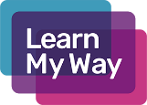
Use Learn My Way to learn how to watch TV online and access catch-up services like BBC iPlayer and 4 on Demand. The course will also teach you how to access the radio online and use music services to listen to your songs whenever you like.
https://www.learnmyway.com/courses/watching-and-listening-online/

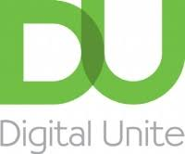
Using the links below from the Digital Unite website will help you to understand how it’s possible to watch TV programmes you’ve missed and films you thought you’d never find again – all online.

https://www.digitalunite.com/technology-guides/tv-video

Look for
Learn more about Watching and listening online with these
https://www.bbc.co.uk/iplayer

https://www.itv.com/

https://www.bbc.co.uk/sounds

The weird and wonderful world of the video website YouTube from Digital Unite
https://www.digitalunite.com/technology-guides/tv-video/youtube

